|  |  |
| --- | --- |
|  | **Genba Sopanrao Moze Trust’s Parvatibai Genba Moze College of Engineering**  **Department of Information Technology** |

Synopsis

# Project Title

Global Stock Market Prediction Based on Stock Chart Images Using Deep Q-Network

# Group Member

Aniruddha Kasar (72151669G) Shrayesh Borkar (72151629H) Aniket Surve (72151721J)

# Sponsorship and External Guide

NA

# Technical Keywords (As per ACM Keywords)

* Deep Learning
* Financial Forecasting
* Stock Market Analysis
* Convolutional Neural Networks (CNNs)
* Machine Vision
* Time Series Analysis
* Cross-Market Prediction
* Financial Data Processing
* Algorithm Optimization
* Investment Strategies
* Market Dynamics
* Data Visualization
* Risk Management

# Problem Statement

. The problem at hand involves the development of a novel approach for stock market prediction using stock chart images. Traditional methods rely on numerical data and financial indicators, but this project aims to leverage the visual information within stock charts. The challenge is to create a Deep Q-Network (DQN) architecture that can effectively learn and predict stock market movements from these images. The model must be versatile, capable of making predictions across various global markets, accounting for different market conditions. Success hinges on training the DQN with a labeled dataset, implementing Convolutional Neural Networks (CNNs) for image feature extraction, and optimizing its performance to provide accurate predictions. This innovative approach has the potential to reshape stock market prediction and impact the financial industry's trading strategies.

1. **Abstract**

In this study, we explore a cutting-edge approach to global stock market prediction, employing Deep Q-Networks (DQNs) in conjunction with Convolutional Neural Networks (CNNs) to harness the predictive power of stock chart images. Traditional methods in the financial industry often rely on numerical data and financial indicators, but this research proposes a novel way to capture market dynamics through visual analysis. We aim to develop a robust DQN architecture that can effectively learn and predict stock market movements while accommodating the inherent complexities of different global markets. The key focus is on image preprocessing, CNN-based feature extraction, and model optimization to deliver accurate predictions. The potential impact of this innovative approach is significant, as it may transform how financial professionals make investment decisions and adapt to dynamic market conditions.

# Goals and Objectives

**1. Data Acquisition Specialist:-** Collect and curate a comprehensive dataset of stock chart images from diverse global stock markets. Ensure data quality, relevance, and completeness.

**2. Deep Learning Engineer:-** Design and develop a robust Deep Q-Network (DQN) architecture that effectively learns from stock chart images to predict stock market movements.

**3. Data Preprocessing Expert:-** Develop and implement image preprocessing techniques to prepare stock chart images for deep learning. Normalize and enhance images to make them suitable for analysis.

**4. Machine Learning Data Scientist:-** Curate and label a high-quality dataset, associating stock chart images with corresponding stock market movements. Implement Convolutional Neural Networks (CNNs) for image feature extraction and model optimization.

**5. Global Market Integration Specialist:-** Ensure that the predictive model is adaptable to different global markets and market conditions. Fine-tune the model to account for variations in data and market dynamics across regions.

* **These roles and objectives collectively contribute to the successful development of an innovative predictive model that can impact the financial industry by providing advanced insights and predictions based on stock chart images.**

# Relevant mathematics associated with the Project.

The project will use the following programming languages and technologies:

**1. Statistics and Data Analysis:-** Statistical methods are crucial for analyzing historical stock data, summarizing trends, and identifying patterns in stock price movements.

**2. Linear Algebra:** Linear algebra is used for matrix operations, which are fundamental in deep learning and neural network computations**.**

**3. Calculus:** Concepts from calculus, such as derivatives, play a role in optimizing machine learning models, including gradient descent for model training.

**4. Probability and Statistics:** Probability theory is essential for understanding the uncertainty and variability in stock market data, while statistical modeling aids in prediction.

**5. Time Series Analysis:** Time series analysis techniques, including autoregressive models and moving averages, are used to model and predict stock price movements over time.

**6. Machine Learning and Deep Learning:** Understanding the mathematical foundations of machine learning, including loss functions, backpropagation, and activation functions, is crucial for building and training deep learning models like Deep Q-Networks.

**7. Convolutional Neural Networks (CNNs):** CNNs involve mathematical operations like convolution and pooling to extract features from stock chart images.

**8. Reinforcement Learning**: Reinforcement learning concepts, including Markov decision processes, Q-learning, and Bellman equations, are used to develop and optimize the Deep Q-Network for stock market prediction.

# Software and hardware requirements for the implementation

## Software Requirements

* **Python:** Python is the primary programming language for data analysis, machine learning, and deep learning. Ensure you have Python installed.
* **Integrated Development Environment (IDE):** Choose an IDE such as Jupyter Notebook, Visual Studio Code, or PyCharm for code development and experimentation.
* **Pandas:** Pandas is a critical library for data manipulation and analysis. Install it to work with data effectively.
* **Numpy:** Numpy is essential for numerical operations and handling arrays. It complements Pandas for data manipulation.
* **Matplotlib and Seaborn:** These libraries are useful for data visualization, enabling you to create plots and charts to analyze data.
* **Scikit-Learn:** Scikit-Learn provides tools for machine learning tasks, including model selection and evaluation.
* **TensorFlow or PyTorch:** Choose a deep learning framework (TensorFlow or PyTorch) to build and train Deep Q-Network models for image analysis.
* **pandas_datareader:** This library allows you to fetch financial data from online sources like Yahoo Finance. It's useful for obtaining stock data.
* **Jinja2:** Jinja2 is used for rendering templates, and it might be required depending on your specific application setup.
* **Streamlit (optional):** If you plan to create a web-based application for your stock market prediction model, you may need Streamlit for the front-end.
* **SQL Database (optional):** If your project includes data storage, you might require a relational database system like SQLite, MySQL, or PostgreSQL.
* **Git (version control):** Use Git for version control to track changes in your project and collaborate with team members.
* **Image Processing Libraries:** If you are working with stock chart images, you may need image processing libraries like OpenCV for pre-processing**.**
* **Operating System:** The software should be compatible with your operating system (e.g., Windows, macOS, or Linux).
* **Text Editor:** A text editor or IDE for writing code and scripts.
* **Dependencies Management:** Use a package manager like pip or conda to manage Python dependencies.
* **Data Sources:** Access to reliable financial data sources, such as Yahoo Finance, for obtaining stock chart images**.**
* **Documentation Tools:** Tools for creating project documentation, such as Markdown or LaTeX.

## Hardware Requirements

* **Processor:** A modern multi-core processor will help speed up development and testing processes
* **Memory (RAM):** At least 8GB of RAM is recommended for Java development. More RAM is beneficial if you are running multiple services simultaneously.
* **Storage:** A fast SSD (Solid State Drive) is preferable for quicker compilation and application loading times.
* **Network Connection:** A reliable internet connection is essential for downloading dependencies, libraries, and updates.
* **Graphics:** A standard graphics card is sufficient for development purposes.

# Innovativeness & Usefulness of Project

Here are some innovative and useful aspects of a:

**Innovativeness:**

**Visual Data Analysis:** The project leverages the innovative idea of using stock chart images, a visual representation of historical stock data, for prediction. This visual data approach is a novel departure from traditional numerical analysis.

**Deep Q-Networks (DQNs):** Applying DQNs in the context of stock market prediction is a novel application of deep reinforcement learning. DQNs have demonstrated their effectiveness in various fields, and using them for financial prediction is an innovative step.

**Cross-Market Prediction:** The project aims to make predictions that are not limited to a single stock market but span across global markets. This approach considers diverse market conditions and is valuable for investors interested in international stocks.

**Usefulness:**

**Advanced Predictive Tools:** The project's outcome, if successful, could provide investors, traders, and financial professionals with an advanced tool for predicting stock market movements. This information can inform trading decisions, risk management, and investment strategies.

**Diverse Applications:** The model's predictive capabilities can be valuable not only for individual investors but also for financial institutions, investment firms, and portfolio managers. It can be used to automate trading strategies or inform asset allocation decisions.

**Risk Mitigation:** The ability to predict stock market movements can help users in risk mitigation. By being aware of potential market shifts, they can make informed decisions to protect their investments.

**Research Implications**: Beyond practical applications, the project contributes to financial and deep learning research. The findings can advance the understanding of how visual data analysis and deep reinforcement learning can be used in stock market prediction.

**Educational Tool:** The project can also serve as an educational tool, showcasing the application of cutting-edge technology in financial analysis and providing a hands-on example of machine learning in finance.

# Names of Conferences / Journals where papers can be published.

**Conferences:**

* **International Conference on Machine Learning (ICML):** A top-tier machine learning conference that covers a wide range of topics, including financial prediction.
* **Conference on Neural Information Processing Systems (NeurIPS):** Another premier machine learning conference where research at the intersection of finance and deep learning is well-received.
* **International Conference on Learning Representations (ICLR):** This conference focuses on representation learning, which is a crucial aspect of deep learning for financial prediction.
* **International Joint Conference on Artificial Intelligence (IJCAI):** IJCAI welcomes research at the intersection of AI and finance, including stock market prediction.
* **ACM SIGKDD Conference on Knowledge Discovery and Data Mining (KDD):** A leading conference in data mining, which is highly relevant for financial data analysis.
* **International Conference on Computational Finance (ICCF):** A specialized conference that focuses on financial modeling and computational techniques.

**Journals:**

* **Journal of Machine Learning Research (JMLR):** A reputable journal for machine learning research, including applications in finance.
* **Journal of Financial Economics:** A leading journal in the field of finance that may accept research on stock market prediction.
* A journal dedicated to quantitative methods in finance, including predictive **Quantitative Finance:** modeling.
* **Neural Networks:** A journal focused on neural networks and deep learning, relevant for your deep Q-network approach.
* **Journal of Financial Data Science:** A journal specifically dedicated to data science in finance and related topics.
* **Expert Systems with Applications:** A journal covering a wide range of applications of expert systems, including financial prediction.

# Review of Conference/Journal Papers supporting Project idea

**Deep Learning Applications in Finance:** Look for papers that discuss the application of deep learning techniques, such as deep neural networks and reinforcement learning, in the financial domain. These papers may offer insights into the use of deep learning for stock market prediction.

**Image Analysis and Finance:** Research papers that explore image analysis or computer vision techniques in financial analysis are relevant. They may not focus on stock market prediction specifically but can provide valuable methods for working with stock chart images.

**Reinforcement Learning in Finance:** Papers discussing the use of reinforcement learning, like Deep Q-Networks, for financial decision-making and prediction can be informative.

**Stock Price Prediction:** Research that delves into various methodologies for predicting stock prices, including traditional methods and machine learning-based approaches.

**Cross-Market Prediction:** Seek studies that address the challenges and opportunities associated with predicting stock market movements across global markets.

**Time Series Analysis in Finance:** Papers on time series analysis techniques in finance can provide foundational knowledge for modeling stock market data.

**Real-World Applications:** Examine papers that describe real-world applications of machine learning in finance, particularly those with a focus on improving trading strategies or investment decisions.

**Evaluation Metrics**: Papers that discuss appropriate evaluation metrics for assessing the performance of predictive models in the financial domain can be helpful.

**Data Sources and Preprocessing:** Research addressing the sources of financial data and techniques for data preprocessing, especially with regard to stock chart images, can be relevant.

1. **SYSTEM ARCHITURE/FLOW DIAGRAM**

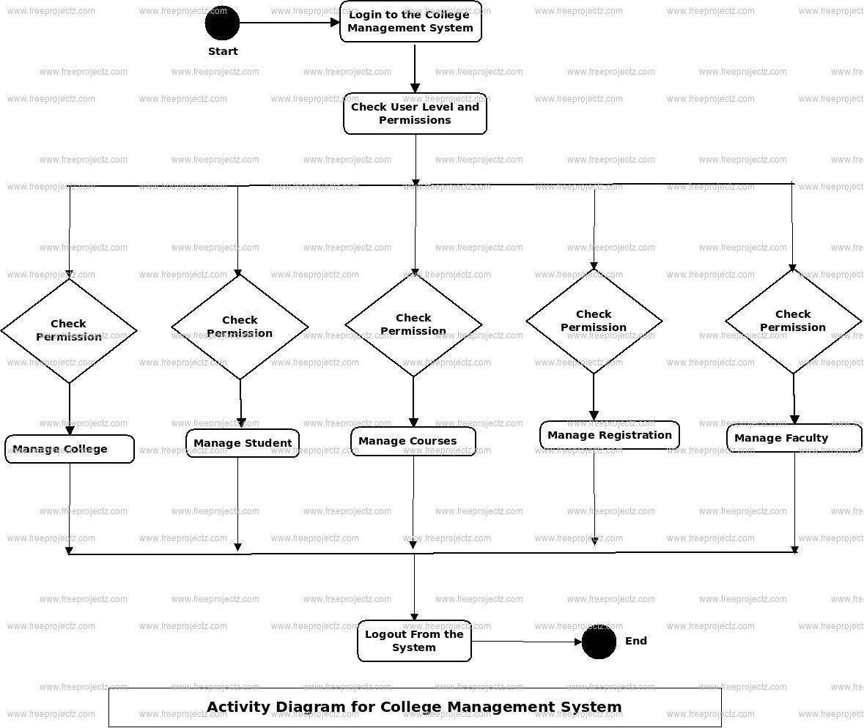

# METHODOLOGY/ALGORITHM USED

**Methodology:**

|  |  |  |
| --- | --- | --- |
| • | **Requirement Analysis** | : Start by understanding the requirements of the college |
| management system, including user roles, features, and data structures.   * **System Design**: Create a system design that outlines the architecture, database schema, user interfaces, and the overall structure of the application. * **Technology Stack**: Choose the appropriate technologies and tools for your Java web application, including Java EE or Spring for the backend, and HTML, CSS, JavaScript, and perhaps a front-end framework like React or Angular for the user interface. * **Database Design**: Design the database schema to store information such as student records, course details, faculty information, and administrative data. Use a relational database system like MySQL or PostgreSQL. * **Backend Development**: Implement the server-side logic using Java. This includes creating RESTful APIs for CRUD (Create, Read, Update, Delete) operations on student records, courses, and other data. * **Frontend Development**: Develop the user interfaces using HTML, CSS, and   JavaScript, and connect them to the backend APIs to display and manipulate data. | | |

**Common Algorithms and Techniques:**

* **Sorting Algorithms**: You may need sorting algorithms for tasks like displaying student records in alphabetical order or sorting course lists.
* **Search Algorithms**: Implement search algorithms for quickly finding specific student records or course details.
* **Database Queries**: Efficiently retrieve data from the database using SQL queries to provide fast responses to user requests.
* **Authentication**: Use secure authentication methods like bcrypt for password hashing and token-based authentication for API security.
* **Authorization**: Implement role-based access control to ensure that users can only access data and features appropriate for their role.
* **Data Validation**: Use input validation techniques to prevent invalid or malicious data from entering the system.
* **Caching**: Implement caching mechanisms to reduce database load and improve application performance.
* **Error Handling**: Implement error-handling strategies to provide meaningful error messages to users and log errors for debugging.
* **Security**: Implement security best practices, including HTTPS, secure coding practices, and regular security audits.
* **Concurrency Control**: If multiple users can access and modify data simultaneously, use techniques like database locks or optimistic concurrency control to avoid conflicts.

1. **Conclusion**

In conclusion, we have seen the many benefits of using a Java-based approach for web development. From improved performance and scalability to enhanced security and ease of use, Java offers a robust and reliable framework for building web applications.

# References

1. Lubling Oz, Malav Leonardo. Developping Scalable, Reliable, Business Applicationwith Servlets. [http://www.javasoft.com/product/servlet/index.html.](http://www.javasoft.com/product/servlet/index.html)
2. Arthur Ryman. Developing Server-Side Java Web Applications, <http://www.javasoft.com/product/servlet>/index.html.
3. Sun Microsystems. JavaServer Pages 0.92 Specification, 1998.
4. Dr Gray L Craig. It's Coupling Stupid: JSP and JavaBeans. [http://www.servletcentrtal.com/.](http://www.servletcentrtal.com/)
5. McKenna Gene. Combining Sessions and Cookies in an Authentication System, http://www.servletcentral. com/.
6. McKenna Gene. Using Voyager with Servlets. [http://www.servletcentral.com/.](http://www.servletcentral.com/)

Li Chunlin is a postgraduate. Her research interests include high-speed networks, multimedia communications and Internet.

.